|  |  |
| --- | --- |
| Tile | Meaning |
|  | Rover 2 |
|  | Rover 0 |
|  | Rover 3 |
|  | Rover 1 |
|  | Lander |
|  |  |
|  | Rock Sample |
|  | Soil Sample |
|  | Objective 1 |
|  | Objectie 0 |

|  |  |  |
| --- | --- | --- |
| Rover | From | To |
|  | 2 | 4 |
| 1 |
| 0 |
| 5 |
| 0 | 3 |
|  | 2 | 4 |
| 0 |
|  | 1 | 0 |
| 3 | 5 |
| 2 |
|  | 3 | 4 |
| 2 |
| 0 | 1 |
| 2 | 5 |
|  | 0 | 1 |
| 2 |
| 2 | 3 |
| 5 |
| 3 | 4 |

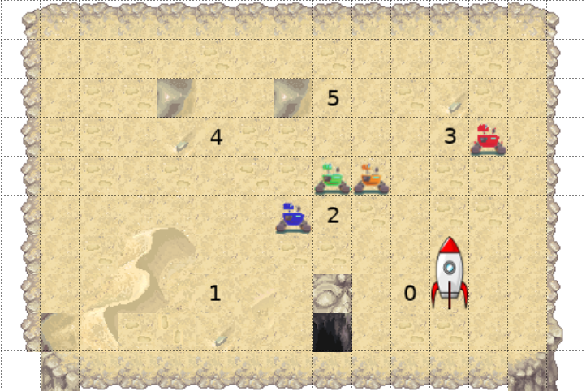

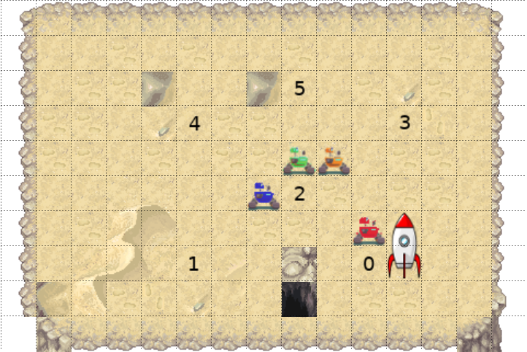

Rover 3 Navigates to position 0

EXP PLANNER INDP: Your camera should focus at the target

Rover 3 Calibrates camera at objective 0

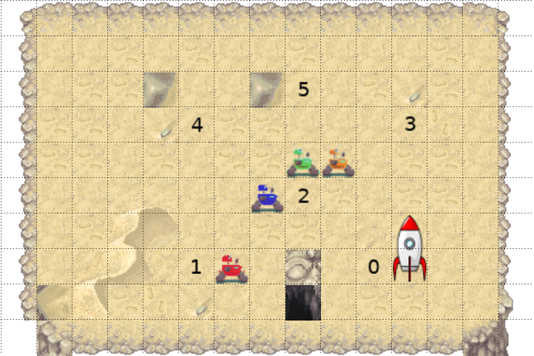

Rover 3 navigates to position 1

EXP PLANNER INDP: To sample soil, rover needs to be equipped with soil analysis tool

EXP: To sample soil, rover needs to be close to the sampling location

Rover Samples soils

Rover 3 Communicates soil data to lander

EXP: To take an image, your camera should stay calibrated towards objective

Rover 3 takes high resolution image from objective 0

Rover 3 communicates data to lander

Rover 1 calibrates camera at objective 0

Rover 2 navigates to position 5

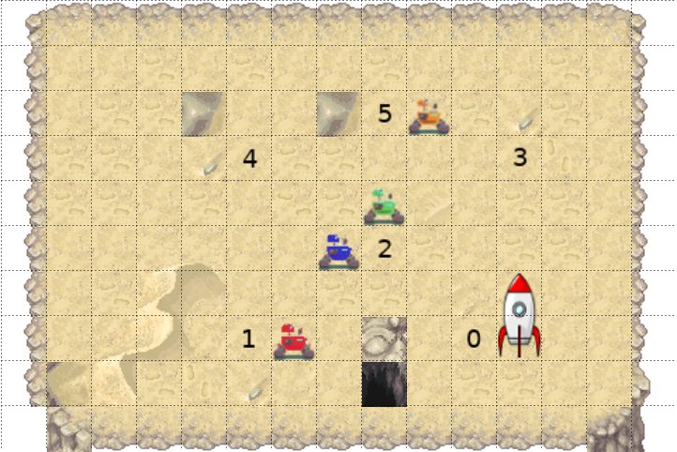

Rover 2 samples rock

Rover 2 navigates to position 2



Rover 2 communicates rock data to lander

Rover 1 takes low resolution image of objective 0

Rover 1 communicates image data of objective 0

Rover 1 calibrates camera at objective 2

Rover 1 takes low resolution image of objective 2

Rover 1 communicates image data of objective 2

Rover 0 navigates to position 4

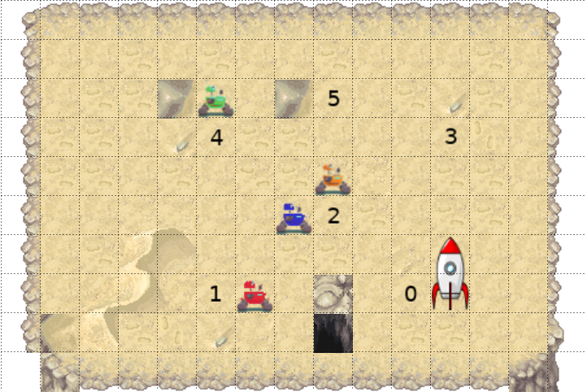

Rover 0 samples soil

Rover 0 communicates soil data to lander

EXP: Drop action can only happen if the rover’s storage is full

EXP PLANNER INDP: You can choose to drop from your stored item

Rover 0 drops the rock sample

Rover 0 samples rock

Rover 0 communicates the rock data to lander

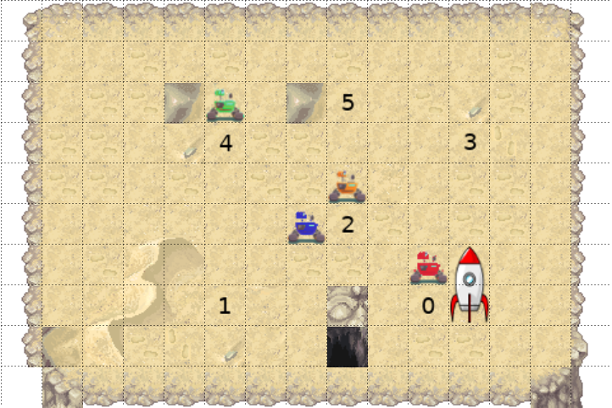

Rover 3 Navigates to position 0

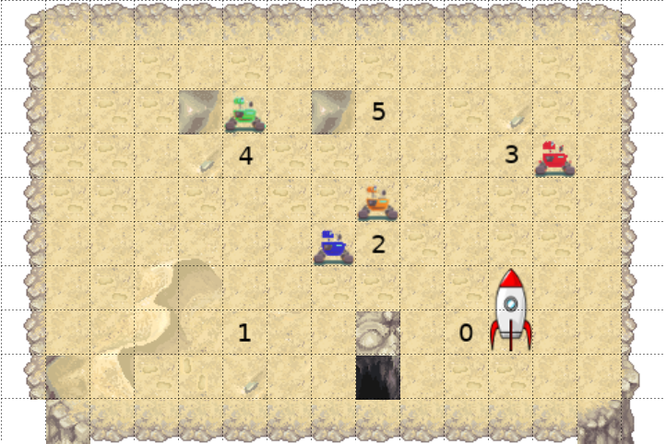

Rover 3 Navigates to position 3

Rover 3 drops the stored sample

Rover 3 samples soil

Rover 3 communicates soil data to lander

**Complete**

EXP: Your camera should focus at the target

EXP: To sample soil, rover needs to be equipped with soil analysis tool

EXP: To take an image, your camera should stay calibrated towards objective

EXP: Drop action can only happen if the rover’s storage is full

EXP: Rover loses the stored sample after dropping

Rover 3 Navigates to position 0

Rover 3 Calibrates camera at objective 0

Rover 3 navigates to position 1

Rover Samples soils

Rover 3 Communicates soil data to lander

Rover 3 takes high resolution image from objective 0

Rover 3 communicates data to lander

Rover 1 calibrates camera at objective 0

Rover 2 navigates to position 5

Rover 2 samples rock

Rover 2 navigates to position 2

Rover 2 communicates rock data to lander

Rover 1 takes low resolution image of objective 0

Rover 1 communicates image data of objective 0

Rover 1 calibrates camera at objective 2

Rover 1 takes low resolution image of objective 2

Rover 1 communicates image data of objective 2

Rover 0 navigates to position 4

Rover 0 samples soil

Rover 0 communicates soil data to lander

Rover 0 drops the rock sample

Rover 0 samples rock

Rover 0 communicates the rock data to lander

Rover 3 Navigates to position 0

Rover 3 Navigates to position 3

Rover 3 drops the stored sample

Rover 3 samples soil

Rover 3 communicates soil data to lander

**Relaxed OEG**

Rover 3 Navigates to position 0

EXP: Your camera should focus at the target

Rover 3 Calibrates camera at objective 0

Rover 3 navigates to position 1

EXP: To sample soil, rover needs to be equipped with soil analysis tool

Rover Samples soils

Rover 3 Communicates soil data to lander

EXP: To take an image, your camera should stay calibrated towards objective

Rover 3 takes high resolution image from objective 0

Rover 3 communicates data to lander

Rover 1 calibrates camera at objective 0

Rover 2 navigates to position 5

Rover 2 samples rock

Rover 2 navigates to position 2

Rover 2 communicates rock data to lander

Rover 1 takes low resolution image of objective 0

Rover 1 communicates image data of objective 0

Rover 1 calibrates camera at objective 2

Rover 1 takes low resolution image of objective 2

Rover 1 communicates image data of objective 2

Rover 0 navigates to position 4

Rover 0 samples soil

Rover 0 communicates soil data to lander

EXP: Drop action can only happen if the rover’s storage is full

EXP: Rover should have a sample in storage before performing drop

Rover 0 drops the rock sample

Rover 0 samples rock

Rover 0 communicates the rock data to lander

Rover 3 Navigates to position 0

Rover 3 Navigates to position 3

Rover 3 drops the stored sample

Rover 3 samples soil

Rover 3 communicates soil data to lander